Java Programming Tasks

Arrays

1. Write a program to find min and max of given integer array in minimum code.

import java.util.*;

public class Main

{

public static void main(String[] args) {

int a[]={10, 20, 30, 7, 4, 8};

Arrays.sort(a);

System.out.println("Max: " +a[a.length-1]);

System.out.println("Min: " +a[0]);

}

}

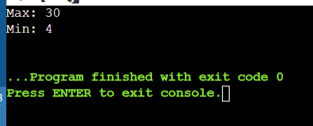

1. Demonstrate for-each loop for an array.

import java.util.Scanner;

public class Arr

{

public static void main(String[] args)

{

int a[]={1, 2, 3, 4, 5};

Scanner sc=new Scanner(System.in);

System.out.println("Elements of the array: ");

for(int i:a)

System.out.println(i);

}

}

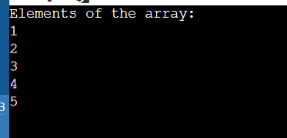

1. Write a program to count even and odd number in an array.

import java.util.Arrays;

public class Arr

{

public static void main(String[] args)

{

int a[]={10, 30, 2, 5, 6, 7};

int e=0, o=0;

Arrays.sort(a);

for(int i:a)

{

if(i%2==0)

{

e++;

}

else

{

o++;

}

}

System.out.println("Even: "+e);

System.out.println("Odd: "+o);

}

}

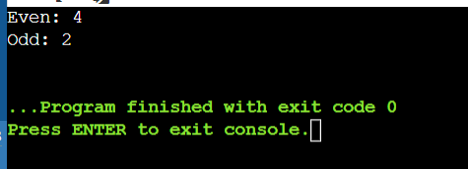

1. Write a program to calculate the sum and average of all the values stored in an integer array.

public class Arr

{

public static void main(String[] args)

{

int a[]={10, 30, 2, 5, 6, 7};

int sum=0;

double avg=0;

for(int i:a)

{

sum+=i;

}

avg=sum/a.length;

System.out.println("Sumn: "+sum);

System.out.println("Average: "+avg);

}

}

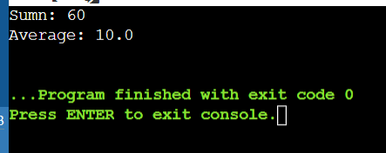

1. Write a program to sort the given integer and sting array.

import java.util.Arrays;

import java.util.Scanner;

public class Arr

{

public static void main(String[] args)

{

int a[]={10, 30, 2, 5, 6, 7};

String s[]={"dog", "rat", "cat", "man"};

System.out.println("Unsorted int array: " +Arrays.toString(a));

Arrays.sort(a);

System.out.println("Sorted int array: "+Arrays.toString(a));

System.out.println("Unsorted string array: " +Arrays.toString(s));

Arrays.sort(s);

System.out.println("Sorted string array: " +Arrays.toString(s));

}

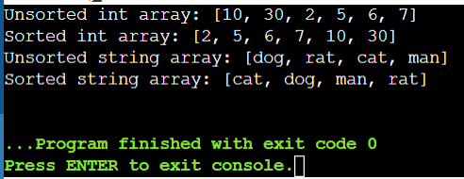

1. Write a program to initialize an array and display it.

import java.util.Scanner;

import java.util.Arrays;

public class Arr

{

public static void main(String[] args)

{

int a[]=new int[10];

Scanner sc=new Scanner(System.in);

System.out.println("Enter Elements: ");

for(int i=0; i<a.length; i++)

{

a[i]=sc.nextInt();

}

System.out.println("The entered Elements: ");

for(int j=0; j<a.length; j++)

{

System.out.println(a[j]+ " ");

}

}

}

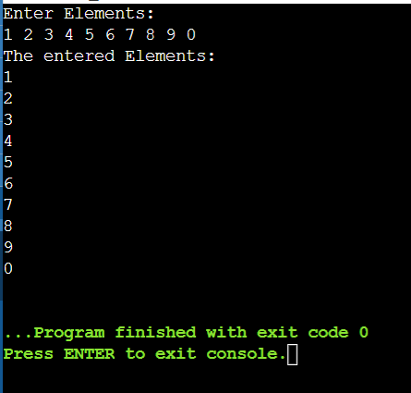

1. Write a program to create a string array and search particular string in it.

import java.util.Scanner;

import java.util.Arrays;

import java.util.*;

public class Arr

{

public static void main(String[] args)

{

String a[]={"dog", "cat", "man"};

System.out.println("Enter Element: ");

Scanner sc=new Scanner(System.in);

String s=sc.nextLine();

for(int i=0; i<a.length; i++)

{

if(s.equals(a[i]))

{

System.out.println(i);

}

}

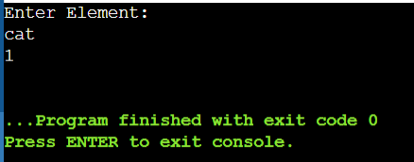

}

}

1. Write a program to demonstrate linear search iin an array.

public class LinearSearchExample

{

public int linearSearch(int[] arr, int key){

for(int i=0; i<arr.length; i++){

if(arr[i] == key){

return i;

}

}

return -1;

}

public static void main(String[] args){

int[]a1= {10, 20, 30, 50, 70, 90};

int key = 60;

LinearSearchExample l1 = new LinearSearchExample();

int i=l1.linearSearch(a1,key);

if(i==-1)

System.out.println(key+" not found.");

else

System.out.println(key+" is found at index: "+l1.linearSearch(a1, key));

}

}

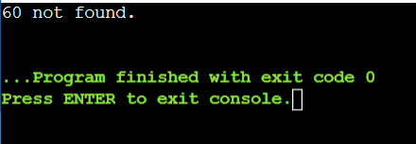

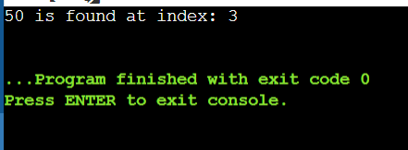

1. Write a program to initialize and print a two-dimensional array.

import java.util.Scanner;

import java.util.Arrays;

import java.util.*;

class TwoDim

{

public static void main(String args[])

{

int[][] a={{10, 20}, {30,40}, {50, 60}};

System.out.println("Two Dimensional array elements are: ");

for(int i=0; i<3; i++)

{

for(int j=0; j<2; j++)

{

System.out.println(a[i][j]);

}

}

System.out.println(Arrays.deepToString(a));

}

}

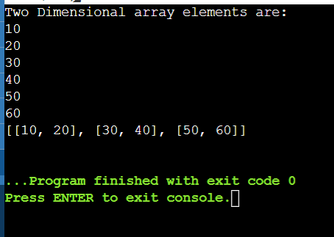

1. Write a program to input element inn a two-dimensional array and display it.

import java.util.Scanner;

import java.util.Arrays;

import java.util.*;

class TwoDim1

{

public static void main(String args[])

{

int [][]a= new int [4][3];

Scanner sc=new Scanner(System.in);

for(int i=0; i<4; i++)

{

for(int j=0; j<3; j++)

{

a[i][j]=sc.nextInt();

}

}

System.out.println("Two Dimensional array elements are: ");

System.out.println(Arrays.deepToString(a));

}

}

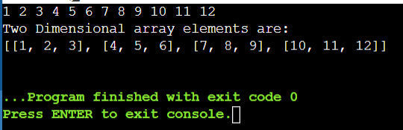

1. Write a program to display the name “Kumar” with different salutations.

class Kumar

{

public static void main(String[] args)

{

String [][] salutation = {{"Mr.", "Mrs.", "Ms."}, {"Kumar"}};

System.out.println(salutation[0][0]+" "+salutation[1][0]);

System.out.println(salutation[0][1]+" "+salutation[1][0]);

System.out.println(salutation[0][2]+" "+salutation[1][0]);

}

}

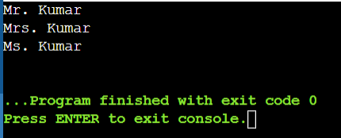

1. Write a program to sum the elements of a two-dimensional array.

public class Board

{

public static void main(String[] args)

{

int[][] board = new int[3][3];

for(int i=0; i<board.length; i++)

{

for(int j=0; j<board[i].length; j++)

{

board[i][j] = i+j;

System.out.println(board[i][j]);

}

}

}

}

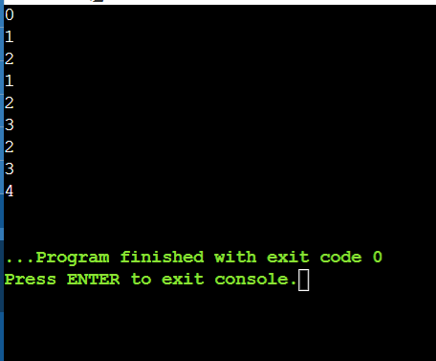

1. Create a class, declare a private member in it; call the private member in another main class.

class Data

{

private String name;

public void set(String n)

{

name=n;

}

public void get()

{

System.out.println("The String is: "+name);

}

}

public class Main1{

public static void main(String[] args)

{

Data d1 = new Data();

d1.set("Hello World!");

d1.get();

}

}

**Alternative:**

class Data  
{  
    private String name;  
     
    public void set(String n)  
    {  
       [this.name](http://this.name/)=n;  
    }  
     
    public String get()  
    {  
        return [this.name](http://this.name/);  
    }  
}  
  
public class Main1{  
    public static void main(String[] args)  
    {  
        Data d1 = new Data();  
        d1.set("Hello World!");  
        d1.get();  
    }  
}

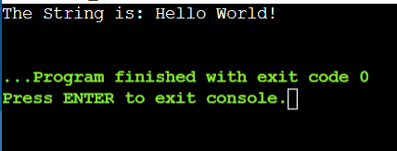

1. Write a program to demonstrate the concept of a parent and child class.

class Animal

{

protected void Display()

{

System.out.println("I am an animal!");

}

}

class Dog extends Animal

{

public static void main(String[] args)

{

Dog dog= new Dog();

dog.Display();

}

}

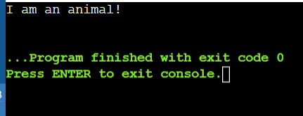

1. Create a program to access a member function in a child class.

class Animal

{

public int legCount;

public void display()

{

System.out.println("i am an animal!");

System.out.println("I have "+legCount+" legs");

}

}

public class Main{

public static void main(String[] args)

{

Animal animal = new Animal();

animal.legCount= 4;

animal.display();

}

}

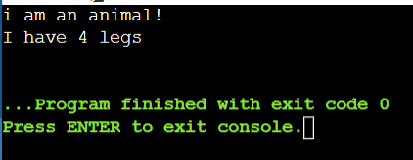

1. Write a program to demonstrate method overriding and inheritance.

class Animal2

{

public void Eat()

{

System.out.println("Eat in parent class");

}

}

class Dog2 extends Animal2

{

public void Eat()

{

System.out.println("Eat in Subclass");

}

public void Bark()

{

System.out.println("Barking!");

}

}

public class Main3

{

public static void main(String[] args)

{

Animal2 a = new Animal2();

a.Eat();

Dog2 d1 = new Dog2();

d1.Eat();

}

}

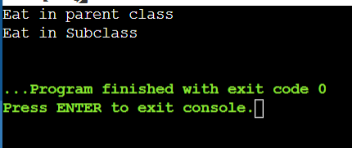

1. To demonstrate method overriding, inheritance and method calling.

class Animal2

{

public void Eat()

{

System.out.println("Eat in parent class");

}

}

class Dog2 extends Animal2

{

public void Eat()

{

System.out.println("Eat in Subclass");

}

public void Bark()

{

System.out.println("Barking!");

}

}

public class Main3

{

public static void main(String[] args)

{

Animal2 a = new Animal2();

a.Eat();

Dog2 d1 = new Dog2();

d1.Eat();

Animal2 c = new Dog2();

c.Eat();

}

}

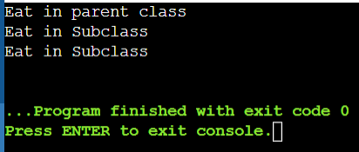

1. Write a program to print the area of a circle and a rectangle using inheritance.
2. class Shape  
   {  
       public void Area()  
       {  
          System.out.println("Area od Different Shapes!") ;  
       }  
   }  
     
   class Circle extends Shape  
   {  
       int r;  
       double pi;  
       public void Area(int r, double pi)  
       {  
           System.out.println("Area of Circle: "+ 2*pi*r);  
       }  
   }  
     
   class Rectangle extends Shape  
   {  
       int l,b;  
       public void Area(int l, int b)  
       {  
           System.out.println("Area of Rectangle: "+l*b);  
       }  
   }  
     
   class Main4  
   {  
       public static void main(String[] args)  
       {  
           Shape s = new Shape();  
           s.Area();  
           Circle c= new Circle();  
           c.Area(3, 3.14);  
           Rectangle r= new Rectangle();  
           r.Area(3,4);  
       }  
   }

